Automated Standard Update Monitoring Solution

Objective:
Develop an automated monitoring solution to periodically capture standard publication/update information from selected standards bodies, compare the newly captured data with the existing internal monitoring database, record changes, and notify subscribed authorised users when relevant updates occur.

Data Source:
CEN:
Examples below, if it is workable, we will provide full list of CEN/TCs
CEN/TC | Title | Source URL
CEN/TC 207 | Furniture | https://standards.cencenelec.eu/ords/f?p=205:75:::::FSP_ORG_ID,FSP_LANG_ID,FSP_EXPORT:6188,25,XLS&cs=1C0F77BD6F199770C140923329CEA88A6
CEN/TC 52 | Safety of Toys | https://standards.cencenelec.eu/ords/f?p=205:75:::::FSP_ORG_ID,FSP_LANG_ID,FSP_EXPORT:6036,25,XLS&cs=1ED4FE4666E18868F7986A60EB2721E84
CEN/TC 93 | Ladders | https://standards.cencenelec.eu/ords/f?p=205:75:::::FSP_ORG_ID,FSP_LANG_ID,FSP_EXPORT:6076,25,XLS&cs=1D2AFC52C44682CDB2BE8010620F523ED

Access method: the source is a downloadable excel file
The excel downloaded, contains the below information:
Reference | Date | Title
EN 16122:2012 | 2012-07-18 | Domestic and non-domestic storage furniture - Test methods for the determination of strength, durability and stability
EN 13721:2023 | 2023-04-26 | Furniture - Assessment of the surface reflectance
EN 1022:2023 | 2023-11-29 | Furniture - Seating - Determination of stability
EN 14434:2023 | 2023-11-22 | Writing boards for educational institutions - Ergonomic, technical and safety requirements and their test methods

Needs to extract and convert into the below format:
标准号+年份  Standard ID + Version | 归口单位代码  TC / SC Code | 标准中文名称  Standard Chinese Title | 标准英文名称  Standard English Title | 发布日期  Publish Date | 实施日期  Implement Date | 标准状态  Status
EN 16122:2012 | CEN/TC 207 |  | Domestic and non-domestic storage furniture - Test methods for the determination of strength, durability and stability | 2012-07-18 |  | Current

- Where an information is not available, i.e. Standard Chinese Title, Implement Date, leave those blank.
- Set status to “Current”

ISO:
Some examples below, if it is workable, we will provide full list of TCs
ISO has TCs and SCs (Subcommittees), provided example for both
TC or SC | Title | Source URL
ISO/TC 136 | Furniture | https://www.iso.org/committee/52448/x/catalogue/p/1/u/0/w/0/d/0
ISO/TC 181 | Safety of Toys | https://www.iso.org/committee/54044/x/catalogue/p/1/u/0/w/0/d/0
ISO/TC 29 SC 5 | Grinding wheels and abrasives | https://www.iso.org/committee/47502/x/catalogue/

Access method: the source is a filterable website, require filtering before website extraction.
On each active webpage, Set Filter to “Published” only:
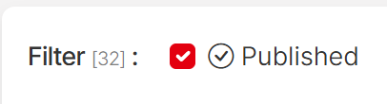
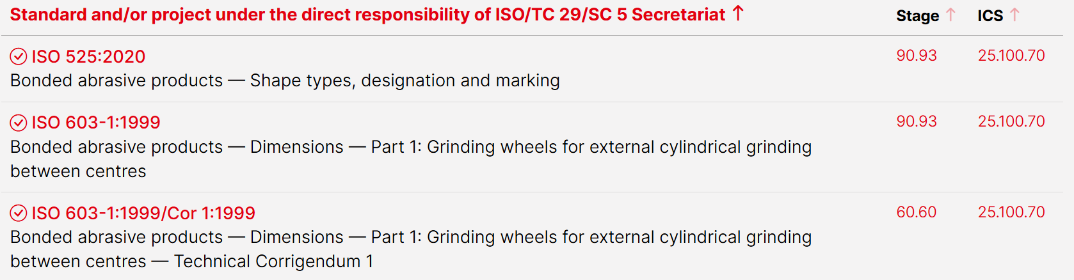
Needs to extract and convert into the below format:
标准号+年份  Standard ID + Version | 归口单位代码  TC / SC Code | 标准中文名称  Standard Chinese Title | 标准英文名称  Standard English Title | 发布日期  Publish Date | 实施日期  Implement Date | 标准状态  Status
ISO 525:2000 | ISO/TC 29/SC 5 |  | Bonded abrasive products – Shape types, designation and marking | 2000 |  | Current

- Where an information is not available, i.e. Standard Chinese Title, Implement Date, leave those blank.
- Publish Date:
  - For first run, input Year info, e.g. 2000
  - For following regular extraction: input Year + Extraction month, e.g. 2026/08, if extraction is done in August.
- Set status to “Current”

ASTM:
SubCommittee | Title | Link
F15.24 | Jewelry | https://www.astm.org/membership-participation/technical-committees/committee-f15/subcommittee-f15/jurisdiction-f1524
F15.22 | Toy Safety | https://www.astm.org/membership-participation/technical-committees/committee-f15/subcommittee-f15/jurisdiction-f1522
F15.42 | Furniture Safety | https://www.astm.org/membership-participation/technical-committees/committee-f15/subcommittee-f15/jurisdiction-f1542

Access method: the source is a website, require website extraction
Each active webpage contains list of standard and their revision status.
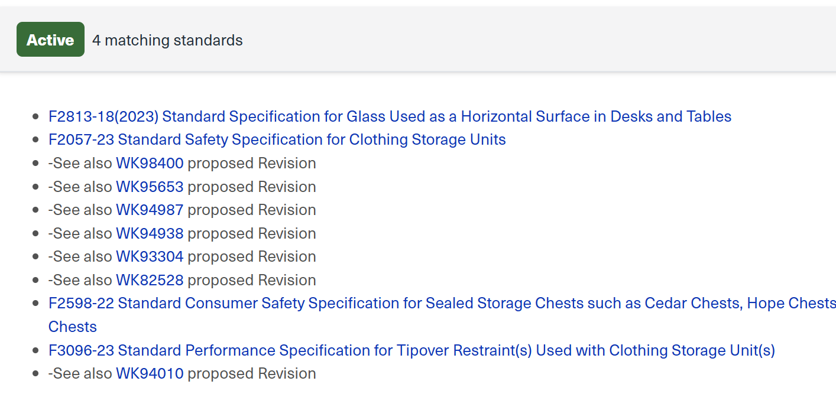
Only need to extract standard information, for example:
F2813-18(2023) Standard Specification for Glass Used as Horizontal Surface in Desks and Tables
18 = first publication year
(2023) = last reaffirmed year, 2023
Ignore, “See also WK…..”

Convert into the below format:
标准号+年份  Standard ID + Version | 归口单位代码  TC / SC Code | 标准中文名称  Standard Chinese Title | 标准英文名称  Standard English Title | 发布日期  Publish Date | 实施日期  Implement Date | 标准状态  Status
ASTM F2813-18(2023) | F15.42 |  | Standard Specification for Glass Used as a Horizontal Surface in Desks and Tables | 2023 |  | Current

- Add “ASTM” to prefix of the Standard ID
- Where an information is not available, i.e. Standard Chinese Title, Implement Date, leave those blank.
- Publish Date:
  - For first run, input Year info, e.g. 2023
  - For following regular extraction: input Year + Extraction month, e.g. 2026/08, if extraction is done in August.
- Set status to “Current”

ASME
https://www.asme.org/codes-standards/find-codes-standards
Access method: the source is a filterable website, require filtering before website extraction
There are four areas we need to monitor:
Go to Designator -> A112 -> A112.18.1/CSA B125.1 -> Apply
Go to Designator -> B94 -> All B94 -> Apply
Go to Designator -> B107 -> All B107 -> Apply
Go to Designator -> PASE -> All PASE -> Apply
Take PASE as an example:
PASE: Standard ID
Safety Standard for Portable Automotive Service Equipment: Standard Title
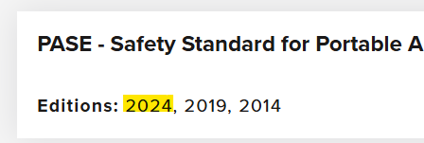: the latest version of year: the version of the year of the standard

Need to extract and convert into the below format:
标准号+年份  Standard ID + Version | 归口单位代码  TC / SC Code | 标准中文名称  Standard Chinese Title | 标准英文名称  Standard English Title | 发布日期  Publish Date | 实施日期  Implement Date | 标准状态  Status
ASME PASE-2024 | PASE |  | Safety Standard for Portable Automotive Service Equipment | 2024 |  | Current

- Add “ASME” to prefix of the Standard ID
- Where an information is not available, i.e. Standard Chinese Title, Implement Date, leave those blank.
- Publish Date:
  - For first run, input Year info, e.g. 2024
  - For following regular extraction: input Year + Extraction month, e.g. 2026/08, if extraction is done in August.
- Set status to “Current”
BIFMA:
https://www.madcad.com/store/?libraryFilterPublisherOnce=BIFMA
Access method: the source is a website, require website extraction
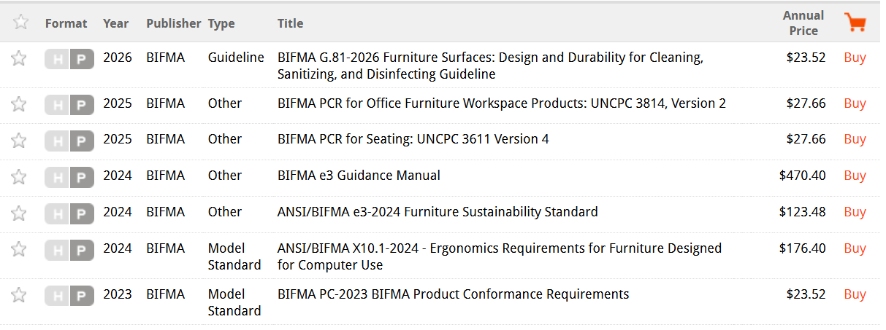
“BIFMA G.81” = Standard ID
Furniture Surfaces: Design and Durability for …. = Standard Title
2026 = Year of Version

Need to extract and convert into the below format:
标准号+年份  Standard ID + Version | 归口单位代码  TC / SC Code | 标准中文名称  Standard Chinese Title | 标准英文名称  Standard English Title | 发布日期  Publish Date | 实施日期  Implement Date | 标准状态  Status
BIFMA G.81-2026 | BIFMA |  | Furniture Surfaces: Design and Durability for …. | 2026 |  | Current

- Where an information is not available, i.e. Standard Chinese Title, Implement Date, leave those blank.
- For Publish Date:
  - For first run, input Year info, e.g. 2026
  - For following regular extraction: input Year + Extraction month, e.g. 2026/08, if extraction is done in August.
- Set status to “Current”

ALI (Ladder Standard)
https://www.americanladderinstitute.org/page/A14Standards
Access method: the source is a website, require website extraction
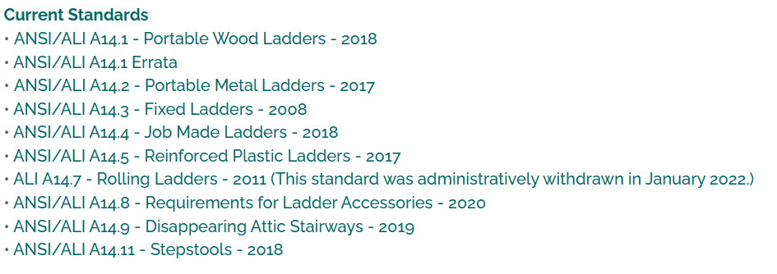
ANSI/ALI A14.1 = Standard ID
Portable Wood Ladder = Standard Title
2018 = Version of Year

Need to extract and convert into the below format:
Status always as “Current”
标准号+年份  Standard ID + Version | 归口单位代码  TC / SC Code | 标准中文名称  Standard Chinese Title | 标准英文名称  Standard English Title | 发布日期  Publish Date | 实施日期  Implement Date | 标准状态  Status
ANSI/ALI A14.1-2018 | ALI |  | Portable Wood Ladder | 2018 |  | Current

- Where an information is not available, i.e. Standard Chinese Title, Implement Date, leave those blank.
- Publish Date:
  - For first run, input Year info, e.g. 2018
  - For following regular extraction: input Year + Extraction month, e.g. 2026/08, if extraction is done in August.
- Set status to “Current”

WSTDA
https://wstda.com/page/products
Access method: the source is a website, require website extraction
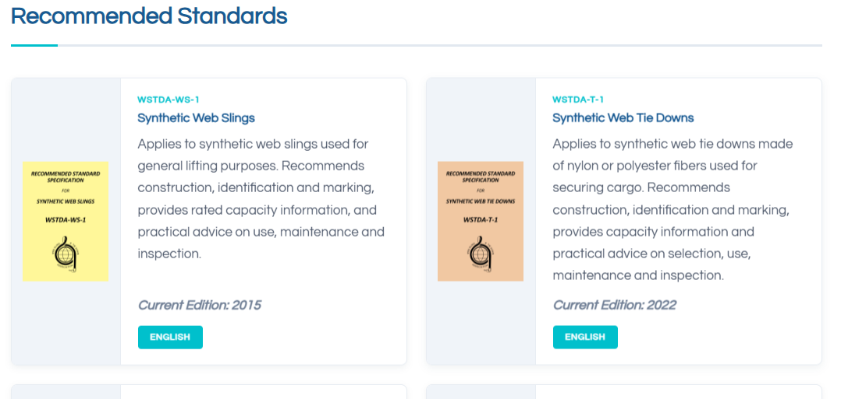
WSTDA-WS-1 = Standard ID
Synthetic Web Slings = Standard Title
Current Edition “2015” = Year of Version

Need to extract and convert into the below format:
Status always as “Current”
标准号+年份  Standard ID + Version | 归口单位代码  TC / SC Code | 标准中文名称  Standard Chinese Title | 标准英文名称  Standard English Title | 发布日期  Publish Date | 实施日期  Implement Date | 标准状态  Status
WSTDA-WS-1-2015 | WSTDA |  | Synthetic Web Slings | 2015 |  | Current

- Where an information is not available, i.e. Standard Chinese Title, Implement Date, leave those blank.
- Publish Date:
  - For first run, input Year info, e.g. 2015
  - For following regular extraction: input Year + Extraction month, e.g. 2026/08, if extraction is done in August.
- Set status to “Current”

Database format:
Proposed format see attached excel
Hopefully in an online database, can set access right for individuals internal users.

First run:
Full extraction of all standard information as given above, set status all to “Current”

Monitoring frequency: TBD

Update Rule:
Compare the extracted data with the existing data in the output for discrepancy:
Compare full information of Standard ID + Version
If a standard in existing data does not match any in the new extraction (regardless it is completely gone, or replaced with a new version)
- Change the standard’s status in the database to “Withdrawn”
If a standard in the new extraction does not match any in the existing database (regardless it is an updated version of an existing standard or a completely new standard)
- Add the standard into our list, set status to “Current” according to the above extraction and conversion format rule.

Example:
The existing database, contains an EN 581-1:1998
In the new run, EN 581-1 is gone from the extracted list, and a new EN 581-1:2026 is captured.
Change Status of EN 581-1:1998 in database to “Withdrawn”
Add a new line to record the new catch EN 581-1:2026, set status to “Current”

Feature of the database:
Subscription and alert:
TÜV SÜD’s authorized employee should be able to subscribe for their interested areas. When there is a change to their interested area, there would be an automatic alert (via email) to the person concerned to inform about the update.
The subscription could be: per standard, per Committee (TC, SC) or per Keywords (to be discussed)
Export option
The Database should be able to be exported into an excel with all columns by administrator roles.

